# **PEEE I Practical Session 1**

Power Supply and Use of Digital Multimeter as Voltmeter

________________________________________________________________________

**1. OBJECTIVES**

* To familiarize with the proper use of a variable dc power supply.
* To measure dc voltages using a digital multimeter as a voltmeter.

**2. EQUIPMENTS**

* Variable dc power supply
* Digital multimeter (DMM)
* Training kit

**3. INTRODUCTION TO DC POWER SUPPLY**

The function of a dc power supply is to supply dc power for electrical and electronic circuits. It can be a better alternative to batteries and dry cells, which will be depleted after prolonged use.

Many different types of power supplies are available. Some are designed as a single-fixed-output power supply, while others provide more features like having more than one output channel and allowing a user to vary the output voltage over a given range. In most cases, power supplies having two or more pairs of output channels allow a user to operate them in independent, series or parallel mode.

The power supply used in this module has three pairs of dc output terminals, namely CH1, CH2 and CH3. Both CH1 and CH2 can provide variable dc output voltages, but the output voltage from CH3 is non-variable and is fixed at 5 V. **Note that CH3 will NOT be used in any experiment in this module.**

**4 PROCEDURE**

4.1 Keep the DC power supply remaining OFF.

4.2 Turn all the knobs on the DC power supply fully counterclockwise to begin with minimum values.

4.3 Set the Operation Mode to Independent by releasing/extending the 2 push buttons below. This ensures that we have **2** independent output channels: CH1 and CH2. We will use CH1 for the start.

4.4 Set the CURRENT knob approximately to the 9 o’clock position. This limits the output current not to be too high, e.g., less than 500 mA.

Note that the current readings displayed on the power supply will not change when you adjust the CURRENT knobs. That is normal. These readings are supposed to be the output current values of the power supply instead of the current limit values.

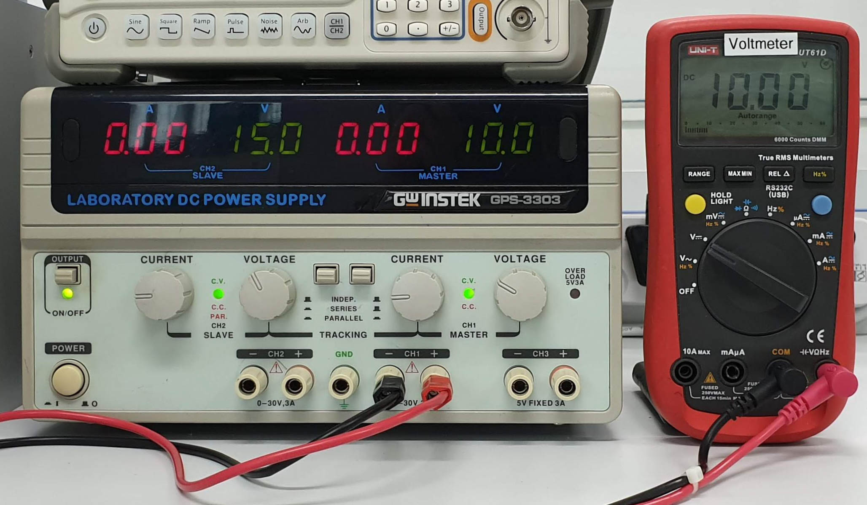

4.5 With a DMM switched to the DC VOLTAGE mode, connect the DMM to the dc power supply to measure the supply voltage. Connect the positive terminal (V) of the DMM to the positive terminal (**+**) of CH1 with a red wire, and connect the negative terminal (COM) of the DMM to the negative terminal (**−**) of CH1 with a black wire.

4.6 Switch ON the dc power supply.

4.7 Press the OUTPUT button to turn on the **green** indicator light.

4.8 Slowly turn the VOLTAGE knob on the power supply clockwise and observe that the voltage reading on the DMM display increases gradually. By doing so, set the CH1 output to 10 volts and the CH2 output to 15 volts.

4.9 Ensure that the CV/CC indicator lights of both CH1 and CH2 turn green. If any indicator light turns red, turn the CURRENT knob to the 9 o’clock position. If the problem still persists, ask your lecturer for help.

CV stands for constant voltage, and CC stands for constant current. A green channel light shows that the output channel is operating as a constant voltage source, and a red channel light shows that the output channel is operating as a constant current source. In this module only constant voltage sources are used in the experiments.

The current readings displayed on the power supply are the output currents of CH1 and CH2. Since the internal resistance of the DMM used as a dc voltmeter is very high (around 10 MΩ), the output current are approximately equal to zero in this experiment.

HBL note: As you are not able to do this Practical in the lab, please watch the video below.

<https://youtu.be/YL08T_p-RHM>

|  |  |
| --- | --- |
|  | Is the voltage reading displayed on the power supply the same as the voltage reading measured by the DMM (Yes/No)? If the answer is No, which voltage reading should we rely on (the power supply meter reading or the voltmeter reading)?  __________________________________________________________  __________________________________________________________  __________________________________________________________ |

**5. CONCLUSION**

_________________________________________________________________________

_________________________________________________________________________

_________________________________________________________________________

_________________________________________________________________________

_________________________________________________________________________